**2P04 2019: Assignment 2**



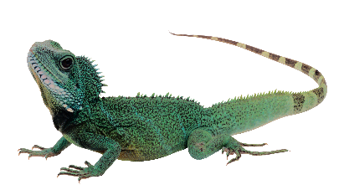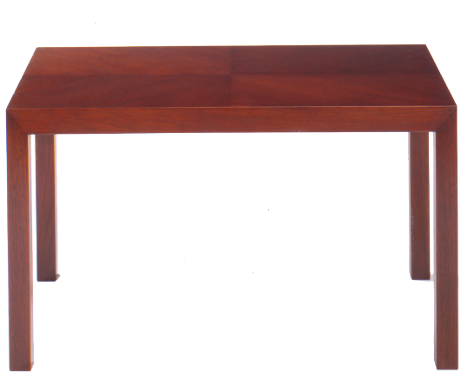

**Fig. 1 Fig. 2**

1. As a wizard, you (Fig. 1) are putting on a magic show to demonstrate your power. The show starts with your 3 kg collapsible wizard lizard wizard cage (filled with a 3 kg lizard wizard) placed on a platform with 3 identical support leg springs, each of which have linear dampers (Fig. 2). When you apply your anti-gravity field spell, the wizard lizard wizard cage's spring extend by 3 cm, rising the cage above its resting position with gravity active to a new resting position without gravity.
   1. [1 mark] Determine the spring constant of each of the 3 identical cage support leg springs.
   2. [2 marks] If the damping constant of each cage support leg is 1.7 N/(m/s), determine whether the system is under-damped, critically-damped, or over-damped.
   3. [10 marks] If the cage is at rest at position 0 at time 0 when you later *suddenly* *remove* the anti-gravity field spell, use both Maple and FlexPDE to show the position, velocity, and acceleration of the cage vs. time for the first 10 seconds after you release it.

Hint: the coordinates are set up so that position = 0 is where it rests with no gravity, meaning it should eventually come to rest with gravity on at -3 cm compared to it's starting position.

Hint: to help see different sized effects on the same graph you can scale some velocity by a factor and acceleration by that factor twice. e.g., in Maple, you might write:

**scale:=10:**

**plot([x,v/scale,a/scale^2], t=0..10, numpoints=1000, legend = ['x','v'/scale, 'a'/scale^2]);**

1. Your biggest magician competitor, The Magnificent Nejat (photo unavailable), is trying to ruin your show. They plan to use an earthquake spell to cause a disturbance that makes the cage shake with where  has units of rad/s.
   1. [1 mark] Determine the natural resonant frequency of the cage (complete with lizard wizard), 
   2. [2 marks] Calculate the amplitude of the force  Nejat must apply to the cage to cause this response amplitude & frequency.
   3. [6 marks] Use Maple and FlexPDE to plot the response (i.e., position, velocity, and acceleration) if Nejat applies this force at time 0 from part 1c).
   4. [6 marks] Rather than applying a force directly, Nejat's earthquake spell actually makes the ground (and table surface) move up and down with an amplitude of 1 mm (also sinusoidally with  as before). Using Maple andFlexPDE determine the position, velocity, and acceleration of the cage for 5 s after Nejat applies this earthquake spell.
2. What Nejat doesn't know is that you're you've set the cage on a magic table that itself is supported with springs and dampers to disrupt his calculations. You have 3 different tables to choose from, each with a different resonant frequency:  respectively. Each table has a mass of 25 kg and is damped with a quality factor of 15.
   1. [6 marks] Determine the [total] spring constant and [total] damping constant for each table (i.e., all legs acting together).
   2. [12 marks] Using either Maple *or* FlexPDE, determine the response (position only) vs. time = 0 to **20 s** of both the table and cage for each table if as before the cage is released from rest at position 0 at time 0 and the earthquake spell is applied to the ground below the table (bottom of the table). *Note:* assume that you've kept the anti-gravity field active on the table, so that the table weight doesn't affect the problem (Hint: this means the only *forces* on the table will be from its springs and dampers below and the cage's springs and dampers above, all of which start at 0 at time 0.)
   3. [2 marks] Determine which table should be used to minimize the final *amplitude* of the cage and why.